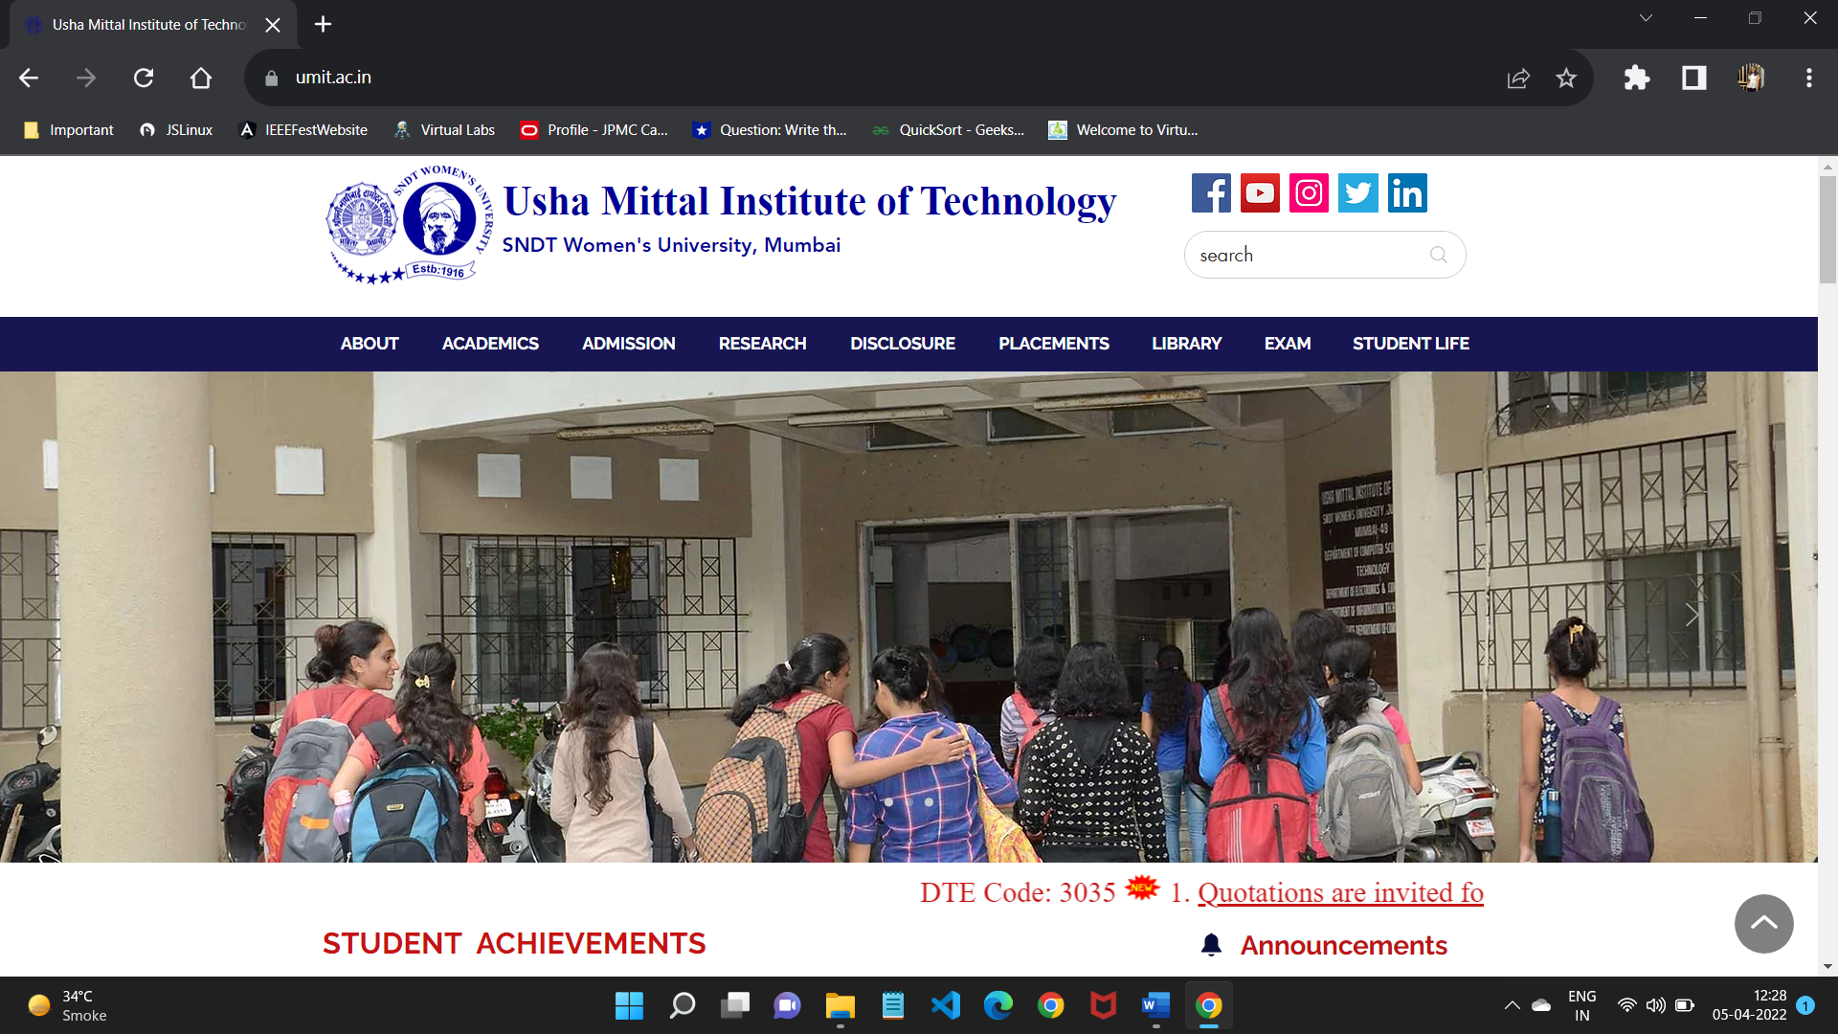 ARTIFICIAL INTELLIGENCE

GADGET RECOMMENDATION USING CLIPS EXPERT SYSTEM

**Prepared By:**

**Name: Simran Santosh Gupta**

**Roll No: 26**

**Sem: VI**

**Branch: Computer Science and Technology**

**INTRODUCTION:**

CLIPS (C Language Integrated Production System) is a widely used expert system development tool that provides a framework for building rule-based systems for knowledge representation, inference, and decision-making. It was developed by NASA's Johnson Space Center in the 1980s and has since become an open-source software widely used in various domains for developing expert systems.

CLIPS provides a rule-based programming language that allows developers to create production rules that represent domain-specific knowledge or expertise. These rules consist of condition-action pairs, where conditions specify the patterns to match in the knowledge base, and actions specify the responses or actions to take when a condition is satisfied. CLIPS uses a forward-chaining inference engine, which iteratively applies rules to the available data or facts until no more rules are triggered, and produces the final conclusions or decisions.

Some key features of CLIPS include:

1. Rule-based Language: CLIPS provides a rich and expressive rule-based language for representing complex knowledge and inference rules, allowing developers to encode domain-specific expertise in a declarative manner.
2. Modularity: CLIPS allows for modular rule development, where rules can be organized into different modules or files, making it easier to manage and maintain large knowledge bases.
3. Inference Engine: CLIPS includes a powerful forward-chaining inference engine that can automatically deduce new conclusions or decisions based on the rules and facts in the knowledge base.
4. Data-driven Reasoning: CLIPS allows developers to define facts or data that represent the current state of the system or domain, and the inference engine can use this data to trigger rules and produce decisions based on the available facts.
5. Extensibility: CLIPS provides an extensible environment that allows developers to define custom functions or procedures in C language, which can be called from within the rule-based system, providing flexibility to incorporate domain-specific processing or calculations.
6. Interoperability: CLIPS supports integration with other programming languages and systems, making it possible to interface with external data sources or perform actions in external systems based on the conclusions reached by the expert system.
7. Community and Resources: CLIPS has a large and active community of users and developers, providing a wealth of resources, documentation, and support for learning and development.

**HOW THE EXPERT SYSTEM WORKS?**

This is a RULE BASED EXPERT SYSTEM

The strength of an expert system derives from its KNOWLEDGE BASE - an organized collection of facts and heuristics about the system's domain. The accumulation of knowledge in knowledge bases, from which conclusions are to be drawn by the INFERENCE ENGINE, is the hallmark of an expert system.

**THE INFERENCE ENGINE:**

1. Combines the facts of a specific case with the knowledge contained in the knowledge base to come up with a recommendation.
2. Directs the user interface to query the user for any information it needs for further inferencing.

**Two strategies are involved:**

1. **Forward chaining –** It is a data-driven strategy. The inferencing process moves from the facts of the case to a goal (conclusion). The strategy is thus driven by the facts available in the working memory and by the premises that can be satisfied. Forward-chaining systems are commonly used to solve more open-ended problems of a design or planning nature, such as, for example, establishing the configuration of a complex product.
2. **Backward chaining -** The inference engine attempts to match the assumed (hypothesized) conclusion - the goal or subgoal state - with the conclusion (THEN) part of the rule. If such a rule is found, its premise becomes the new subgoal. In an ES with few possible goal states, this is a good strategy to pursue. Backward chaining is best suited for applications in which the possible conclusions are limited in number and well defined. Classification or diagnosis type systems, in which each of several possible conclusions can be checked to see if it is supported by the data, are typical application

This – Gadget Based Recommendation System is a Forward Chaining Expert System.

**PURPOSE:**

The purpose of using CLIPS is to develop a model for Mobile/Tablet/Phablet Recommendation System based on rule based Expert System. As the name suggests, the Mobile/Tablet/Phablet Recommendation System helps the user in choosing a Mobile/Tablet/Phablet that is best suited for his/her budget. The expert system will ask various questions to the user and according to the answers received, the system will give the output i.e., the name of the Mobile/Tablet/Phablet along with its price. The document will explain the purpose and features of the system. It also explains the interfaces of the system, what the system will do, and how the system will react to external user.

**The rules for MOBILE/TABLET/PHABLET Recommendation System are as follows:**

1. If Mobile and Under 10k and Xiaomi then suggestion is Redmi 3s Prime (₹8999)

2. If Mobile and Under 10k and Asus then suggestion is Zenfone Max (₹9500)

3. If Mobile and Under 10k and Lenovo then suggestion is Lenovo Vibe K5 (₹6999)

4. If Mobile and Between 10k - 15k and Lenovo then suggestion is Lenovo K5 Note (₹12000)

5. If Mobile and Between 10k - 15k and Motorola then suggestion is G4 Plus (₹14000)

6. If Mobile and Between 10k - 15k and Samsung then suggestion is Galaxy J7 (₹14500)

7. If Mobile and Between 15k - 25k and One Plus then suggestion is One Plus 2 (₹19999)

8. If Mobile and Between 15k - 25k and Samsung then suggestion is J7 Prime (₹18500)

9. If Mobile and Between 15k - 25k and Xiaomi then suggestion is Mi5 (₹22999)

10. If Mobile and Above 25k and One Plus then suggestion is One Plus 3 (₹27999)

11. If Mobile and Above 25k and Samsung then suggestion is Galaxy S7 (₹50000)

12. If Mobile and Above 25k and Apple then suggestion is iphone 7(₹69999) or iphone6 (₹41000)

13. If Tablet and Above 20k and Apple then suggestion is ipad Air 2 (₹39000)

14. If Tablet and Above 20k and Samsung then suggestion is Galaxy Tab Pro (₹49000)

15. If Tablet and Above 20k and Lenovo then suggestion is Yoga Tab 3 (₹45999)

16. If Tablet and Under 20k and Asus then suggestion is Asus ZenPad 8 (₹17999)

17. If Phablet and Above 15k and Xiaomi then suggestion is Mi Max Prime (₹19999)

18. If Phablet and Above 15k and Lenovo then suggestion is Phab 2 Plus (₹15999)

19. If Phablet and Above 15k and Huawei then suggestion is Mate 8 (₹47999)

20. If Phablet and Under 15k then suggestion is Micromax Canvas 5 e481 (₹7699)

**CODE: project.clp**

;----------------------------------------------------------------------------

; CLASSES

;----------------------------------------------------------------------------

(defclass PERSON

(is-a USER)

(role concrete)

(slot company)

(slot devicetype))

(defclass DEVICENAME

(is-a USER)

(slot company)

(slot price)

(slot suggested_device))

;----------------------------------------------------------------------------

; DEFAULT INSTANCES

;----------------------------------------------------------------------------

(definstances PERSON-INSTANCES

(client of PERSON))

(definstances DEVICE-INSTANCES

(which_device of DEVICENAME))

;----------------------------------------------------------------------------

; INITIAL USER INPUTS AND VALIDATIONS

;----------------------------------------------------------------------------

(deffunction user-input-validation (?question $?valid-input)

(printout t ?question)

(bind ?answer (read))

(if (lexemep ?answer)

then (bind ?answer (lowcase ?answer)))

(while (not (member ?answer ?valid-input)) do

(printout t "Please enter a valid input as mentioned in the question!" crlf)

(printout t ?question)

(bind ?answer (read))

(if (lexemep ?answer)

then (bind ?answer (lowcase ?answer))))

?answer)

; RULE TO GET THE USER INPUT

(defrule GetCompanion(declare (salience 10))

=>

(printout t crlf)

(printout t "--------------------------------------------------------------------------------------------------------" crlf)

(printout t "------------------------ WELCOME TO THE SMARTPHONES / TABLETS / PHABLETS EXPERT ------------------------" crlf)

(printout t "--------------------------------------------------------------------------------------------------------" crlf)

(printout t crlf)

(send [client] put-devicetype

(user-input-validation "What do you want to buy? (mobile/tablet/phablet): "mobile tablet phablet)))

;----------------------------------------------------------------------------

; RULES OF THE EXPERT SYSTEM TO SELECT THE DEVICE

;----------------------------------------------------------------------------

; RULE TO SELECT PERFECT MOBILE PHONE

(defrule buy_mobile

?ins <- (object (is-a PERSON) (devicetype mobile))

=>

(printout t crlf)

(printout t "Let me select a Mobile suitable to buy in your budget..." crlf crlf)

(send [which_device] put-price

(user-input-validation "Enter your preferred Price Range (under10k/ 10k-15k / 15k-25k / above25k): "

under10k 10k-15k 15k-25k above25k)))

; RULE TO SELECT PERFECT TABLET

(defrule buy_tablet

?ins <- (object (is-a PERSON) (devicetype tablet))

=>

(printout t crlf)

(printout t "Let me select a Tablet suitable to buy in your budget..." crlf crlf)

(send [which_device] put-price

(user-input-validation "Enter your preferred Price Range (under20k / above20k): "

under20k above20k)))

; RULE TO SELECT PERFECT PHABLET

(defrule buy_phablet

?ins <- (object (is-a PERSON) (devicetype phablet))

=>

(printout t crlf)

(printout t "Let me select a Phablet suitable to buy in your budget..." crlf crlf)

(send [which_device] put-price

(user-input-validation "Enter your preferred Price Range (under15k / above15k): "

under15k above15k)))

; RULE TO TABLET ABOVE 20K

(defrule tab_above20k

(and ?ins <- (object (is-a DEVICENAME) (price above20k))

(object (is-a PERSON)(devicetype tablet)))

=>

(printout t crlf)

(printout t "Let me select a Tablet above 20k..." crlf crlf)

(send [which_device] put-company

(user-input-validation "Enter your preferred company (apple/samsung/lenovo): "

apple samsung lenovo)))

; RULE TO TABLET UNDER 20K

(defrule tab_under20k

(and ?ins <- (object (is-a DEVICENAME) (price under20k))

(object (is-a PERSON)(devicetype tablet)))

=>

(printout t crlf)

(printout t "Let me select a Tablet under 20k..." crlf crlf)

(send [which_device] put-company

(user-input-validation "Enter your preferred company (asus): "

asus)))

; RULE TO PHABLET ABOVE 15K

(defrule phab_above15k

(and ?ins <- (object (is-a DEVICENAME) (price above15k))

(object (is-a PERSON)(devicetype phablet)))

=>

(printout t crlf)

(printout t "Let me select a Phablet above 15K..." crlf crlf)

(send [which_device] put-company

(user-input-validation "Enter your preferred company (xiaomi/lenovo/huawei): "

xiaomi lenovo huawei)))

; RULE TO PHABLET UNDER 15K

(defrule phab_under15k

(and ?ins <- (object (is-a DEVICENAME) (price under15k))

(object (is-a PERSON)(devicetype phablet)))

=>

(printout t crlf)

(printout t "Let me select a Phablet under 15K..." crlf crlf)

(send [which_device] put-company

(user-input-validation "Enter your preferred company (micromax): "

micromax)))

; RULE TO MOBILE UNDER 10K

(defrule mob_under10k

(and ?ins <- (object (is-a PERSON) (devicetype mobile))

(object (is-a DEVICENAME) (price under10k)))

=>

(printout t crlf)

(printout t "Let me select a Mobile Phone Under 10K..." crlf crlf)

(send [client] put-company

(user-input-validation "Select your preferred company(xiaomi/asus/lenovo): "

xiaomi asus lenovo)))

; RULE TO MOBILE 10K - 15K

(defrule mob_10k15k

(and ?ins <- (object (is-a PERSON) (devicetype mobile))

(object (is-a DEVICENAME) (price 10k-15k)))

=>

(printout t crlf)

(printout t "Let me select a Mobile Phone in range 10K - 15K..." crlf crlf)

(send [client] put-company

(user-input-validation "What is your preferred comapny? (lenovo/motorola/samsung): "

lenovo motorola samsung)))

; RULE TO MOBILE 15K - 25K

(defrule mob_15k25k

(and ?ins <- (object (is-a PERSON) (devicetype mobile))

(object (is-a DEVICENAME) (price 15k-25k)))

=>

(printout t crlf)

(printout t "Let me select a Mobile Phone in range 15K - 25K..." crlf crlf) (send [client] put-company

(user-input-validation "What is your preferred company? (oneplus/samsung/xiaomi): "

oneplus samsung xiaomi)))

; RULE TO MOBILE ABOVE 25K

(defrule mob_above25k

(and ?ins <- (object (is-a PERSON) (devicetype mobile))

(object (is-a DEVICENAME) (price above25k)))

=>

(printout t crlf)

(printout t "Let me select a Mobile Phone above 25k..." crlf crlf)

(send [client] put-company

(user-input-validation "What is your preferred company? (oneplus/samsung/apple): "

oneplus samsung apple)))

; RULE TO BUY MOBILE XIAOMI UNDER 10K

(defrule mob_xiaomi_under10k

(and ?ins <- (object (is-a PERSON) (devicetype mobile) (company xiaomi))

(object (is-a DEVICENAME) (price under10k)))

=>

(send [which_device] put-suggested_device "Xiaomi Redmi 3S Prime (Rs.8999/-)"))

; RULE TO BUY MOBILE ASUS UNDER 10K

(defrule mob_asus_under10k

(and ?ins <- (object (is-a PERSON) (devicetype mobile) (company asus))

(object (is-a DEVICENAME) (price under10k)))

=>

(send [which_device] put-suggested_device "Asus Zenfone Max (Rs.9500/-)"))

; RULE TO BUY MOBILE LENOVO UNDER 10K

(defrule mob_lenovo_under10k

(and ?ins <- (object (is-a PERSON) (devicetype mobile) (company lenovo))

(object (is-a DEVICENAME) (price under10k)))

=>

(send [which_device] put-suggested_device "Lenovo Vibe K5 (Rs.6999/-)"))

; RULE TO BUY MOBILE LENOVO 10K-15K

(defrule mob_lenovo_10k15k

(and ?ins <- (object (is-a PERSON) (devicetype mobile) (company lenovo))

(object (is-a DEVICENAME) (price 10k-15k)))

=>

(send [which_device] put-suggested_device "Lenovo K5 Note (Rs.11999/-)"))

; RULE TO BUY MOBILE MOTOROLA 10K-15K

(defrule mob_motorola_10k15k

(and ?ins <- (object (is-a PERSON) (devicetype mobile) (company motorola))

(object (is-a DEVICENAME) (price 10k-15k)))

=>

(send [which_device] put-suggested_device "Moto G4 Plus (Rs. 13999/-)"))

; RULE TO BUY MOBILE SAMSUNG 10K-15K

(defrule mob_samsung_10k15k

(and ?ins <- (object (is-a PERSON) (devicetype mobile) (company samsung))

(object (is-a DEVICENAME) (price 10k-15k)))

=>

(send [which_device] put-suggested_device "Samsung Galaxy J7 (Rs. 14990/-)"))

; RULE TO BUY MOBILE ONE PLUS 15K - 25K

(defrule mob_oneplus_15k25k

(and ?ins <- (object (is-a PERSON) (devicetype mobile) (company oneplus))

(object (is-a DEVICENAME) (price 15k-25k)))

=>

(send [which_device] put-suggested_device "One Plus 2 (Rs. 19999/-)"))

; RULE TO BUY MOBILE SAMSUNG 15K - 25K

(defrule mob_samsung_15k25k

(and ?ins <- (object (is-a PERSON) (devicetype mobile) (company samsung))

(object (is-a DEVICENAME) (price 15k-25k)))

=>

(send [which_device] put-suggested_device "Samsung Galaxy J7 Prime (Rs. 18499/-)"))

; RULE TO BUY MOBILE XIAOMI 15K - 25K

(defrule mob_xiaomi_15k25k

(and ?ins <- (object (is-a PERSON) (devicetype mobile) (company xiaomi))

(object (is-a DEVICENAME) (price 15k-25k)))

=>

(send [which_device] put-suggested_device "Xiaomi Mi5 (Rs. 22999/-)"))

; RULE TO BUY MOBILE ONE PLUS ABOVE 25K

(defrule mob_oneplus_above25k

(and ?ins <- (object (is-a PERSON) (devicetype mobile) (company oneplus))

(object (is-a DEVICENAME) (price above25k)))

=>

(send [which_device] put-suggested_device "One Plus 3 (Rs. 27999/-)"))

; RULE TO BUY MOBILE SAMSUNG ABOVE 25K

(defrule mob_samsung_above25k

(and ?ins <- (object (is-a PERSON) (devicetype mobile) (company samsung))

(object (is-a DEVICENAME) (price above25k)))

=>

(send [which_device] put-suggested_device "Samsung Galaxy S7 Edge (Rs. 50899/-)"))

; RULE TO BUY MOBILE APPLE ABOVE 25K

(defrule mob_lenovo_above25k

(and ?ins <- (object (is-a PERSON) (devicetype mobile) (company apple))

(object (is-a DEVICENAME) (price above25k)))

=>

(send [which_device] put-suggested_device "Apple Iphone 6s (Rs. 41000/-) OR Apple Iphone 7 (Rs. 69999/-)"))

; RULE TO BUY TABLET UNDER 20K

(defrule tab_asus_under20k

(and ?ins <- (object (is-a DEVICENAME) (price under20k) (company asus))

(object(is-a PERSON)(devicetype tablet)))

=>

(send ?ins put-suggested_device "Asus ZenPad 8 (Rs. 17999/-)") )

; RULE TO BUY APPLE TABLET ABOVE 20K

(defrule tab_apple_above20k

(and ?ins <- (object (is-a PERSON) (devicetype tablet))

(object (is-a DEVICENAME) (company apple)(price above20k)))

=>

(send [which_device] put-suggested_device "Ipad Air 2 (Rs. 38999/-) OR Ipad Pro (Rs. 69999/-)"))

; RULE TO BUY SAMSUNG TABLET ABOVE 20K

(defrule tab_samsung_above20k

(and ?ins <- (object (is-a PERSON) (devicetype tablet))

(object (is-a DEVICENAME) (company samsung)(price above20k)))

=>

(send [which_device] put-suggested_device "Samsung Galaxy Tab Pro (Rs. 48999/-)"))

; RULE TO BUY LENOVO TABLET ABOVE 20K

(defrule tab_lenovo_above20k

(and ?ins <- (object (is-a PERSON) (devicetype tablet))

(object (is-a DEVICENAME) (company lenovo)(price above20k)))

=>

(send [which_device] put-suggested_device "Lenovo Yoga Tab 3 (Rs. 45999/-)"))

; RULE TO BUY XIAOMI PHABLET ABOVE 15K

(defrule phab_xiaomi_above15k

(and ?ins <- (object (is-a DEVICENAME) (price above15k)(company xiaomi))

(object (is-a PERSON) (devicetype phablet)))

=>

(send ?ins put-suggested_device "Xiaomi Mi Max Prime (Rs. 19999/-)"))

; RULE TO BUY LENOVO PHABLET ABOVE 15K

(defrule phab_lenovo_above15k

(and ?ins <- (object (is-a DEVICENAME) (price above15k)(company lenovo))

(object (is-a PERSON) (devicetype phablet)))

=>

(send ?ins put-suggested_device "Lenovo Phab 2 Plus (Rs. 15999/-)"))

; RULE TO BUY HUAWEI PHABLET ABOVE 15K

(defrule phab_huawei_above15k

(and ?ins <- (object (is-a DEVICENAME) (price above15k)(company huawei))

(object (is-a PERSON) (devicetype phablet)))

=>

(send ?ins put-suggested_device "Huawei Mate 8 (Rs. 49999/-)"))

; RULE TO BUY PHABLET UNDER 15K

(defrule phab_under15k_micromax

(and ?ins <- (object (is-a DEVICENAME) (price under15k)(company micromax))

(object (is-a PERSON) (devicetype phablet)))

=>

(send ?ins put-suggested_device "Micromax Canvas 5 E481 (Rs. 7699/-)")

(printout t crlf)

(printout t "Let me select a Phablet Under 15K..." crlf))

;----------------------------------------------------------------------------

; PRINTS THE FINAL SUGGESSION

;----------------------------------------------------------------------------

; RULE TO PRINT THE SUGGESTED DEVICE

(defrule choose_device (declare (salience -1))

(object (is-a DEVICENAME) (suggested_device ?mov))

=>

(printout t crlf)

(printout t "-------------------------------------------------------------------------------------------------------------------------------" crlf)

(printout t "The recommended Device which best suits your needs is: " ?mov crlf)

(printout t "-------------------------------------------------------------------------------------------------------------------------------" crlf))

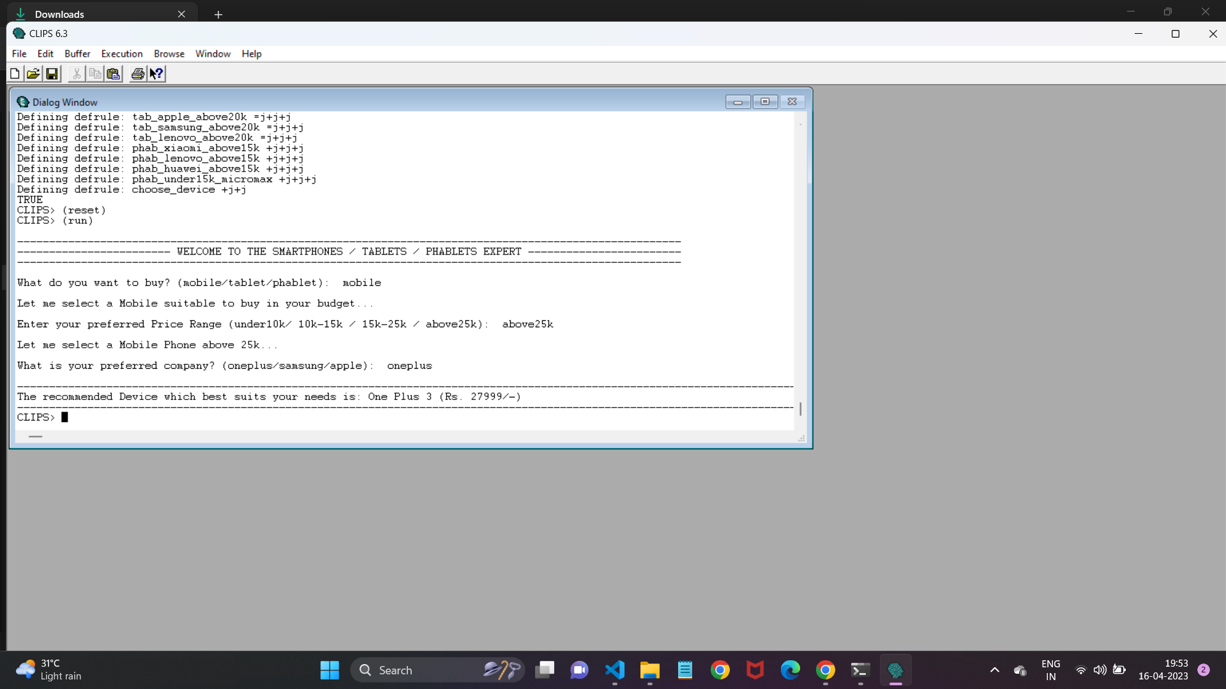**OUTPUT:**

**SCOPE:**

With new brands entering every fortnight, there is a flood of smartphones in the market. As a result, the users are perplexed and they have no expert solution to help them out. This expert system will help them to choose a smartphone that is best for his/her budget. The system also helps those users who do not have a sound knowledge of the gadgets and generally gets fooled by the local shopkeepers who convince them to buy a smartphone providing them with higher profits.

The project involves Mobile/Tablet/Phablet Recommendation System based on rule based Expert System. It recommends in the domain of interest based on company preference and pricing. For a given set of input, recommendation system recommends the gadget based on rules and facts in knowledge base. By improving the knowledge base recommendation can be further refined.

**CONCLUSION:**

Overall, CLIPS is a powerful and flexible tool for developing rule-based expert systems that can be used in a wide range of applications, from decision support systems to diagnostics, planning, and control systems. It provides a rich and expressive language for representing domain-specific knowledge, and its forward-chaining inference engine allows for efficient and automated reasoning based on the available facts and rules. CLIPS continues to be a popular choice for developing expert systems due to its modularity, extensibility, and community support.

**REFERENCES:**

[1] <https://www.csee.umbc.edu/portal/clips/tutorial/>

[2] https://github.com/B-arryAllen/Gadget-Recommendation-Expert-System